**Team Contract**

***Updated February 22nd 2020: A group vote was conducted for the consent of an Electronic Signature to take the place of a written one. The agreement can be found below***

***Updated February 24th, 2020: A group vote was conducted for the addition of Joel Berain as a team member, as well as his role in the project.***

**1) Title and Members**

**Park - It – CDA,** a senior capstone group at the University of Idaho in Coeur d’Alene, is:

**Tyrel Parker:** ([park0210@vandals.uidaho.edu](mailto:park0210@vandals.uidaho.edu))

**Nikolai Tiong:** ([tion4994@vandals.uidao.edu](mailto:tion4994@vandals.uidao.edu))

**Zane Goodrick:** ([zane1634@vandals.uidaho.edu](mailto:zane1634@vandals.uidaho.edu))

**Joel Berain:** ([bera6278@vandals.uidaho.edu](mailto:bera6278@vandals.uidaho.edu))

**Our Goal:**

To provide an intuitive means of visual indication for commuters who are looking for available parking within a specific garage in downtown Coeur d’Alene.

**2) Division of Responsibilities:**

**2a) Selection and Overview of Roles:**

Roles were selected by combination of personal experience, preference and educational aspirations.

**Tyrel Parker:**

* Budgeting of funds
* Simulation of environment/unit functionality

**Nikolai Tiong:**

* Mesh network development
* Customer contact
* Logging of meetings/interviews

**Zane Goodrick:**

* Vehicle detection sensor(s)/software
* Design and production of unit/housing

**Joel Berain:**

* VNC display of garage for final demonstration purposes
* Park-It-CDA Wiki Page

***Each Team member will complete 1/4 of necessary documentation, as well as a personal journal. Overlap of main roles and responsibilities may also occur.***

**2b) Description of Roles:**

**Budgeting of funds –** The total amount spent on the project should be at/under $3000. All parts, components, materials, etc. will need to be approved by the customer before being purchased.

**Simulation of environment/unit functionality –** The project deliverable calls for 5 prototypes of the Park-it-CDA garage sensor units. To understand the complete application of the project (i.e. a whole garage full of units), the environment, the rest of the units, and the data collected from commuters will need to be simulated.

**Mesh Network –** Each unit will be able to transmit and receive data regarding its current state, as well as a timestamp or unit identification number. At any given time, one unit will be the “gateway” unit, which will send the current state/data of all units to a server. Units will need to have the ability to communicate between themselves and be able to assume/relinquish the role of gateway. These communications will be done by means of a mesh network.

**Customer Contact –** One team member will be primarily responsible for communication to the customer, on behalf of the team. This team member will arrange, as well as lead, all meetings with the customer.

**Logging of meetings/interviews –** This team member will take notes during all meetings with the team, instructor, customer, etc. where the information may need to be recounted later.

**Vehicle detection –** Each unit will be able to detect the presence of a vehicle within a garage stall, and indicate the state of the stall to the commuter via LED. Hardware will also be used to allow wireless communication between units. More sensors may be required for accuracy/redundancy of vehicle detection, and all hardware will be controlled via a microprocessor. Software will need to be designed to ensure that the sensors/modules are operating in a way that is consistent with the project specifications.

**Design and production of unit/housing –** Each unit will need to be in a secured enclosure, resistant to weather conditions, and be operational for at least 1 year via batteries.

**VNC display of garage –** For the expo, a live and real-time display of the Coeur d’ Alene parking garage where the system is deployed, will be visible. This means establishing a secure connection with the host PC, and displaying the status of the units.

**Wiki Page –** The Park-It-CDA wiki page website: an easily traversable site which will be host to pertinent team information and deliverables.

**3. Team standards:**

**3a. Productivity:**

Members of the team agree to work independently, at a pace that is consistent with that of other team members, while also ensuring that all work delivered is of quality, meets the specifications, and is submitted on time. Members also agree to contact other team members, and possibly the instructor/customer, early and often, if the above requirements cannot be met for any reason.

**3b. Ethics:**

Team members agree to respect each other. All meetings and other interactions should be conducted in a manner that is beneficial to the overall flow and well-being of the project and its members. Criticisms should be helpful, and disagreements should be resolved in a friendly fashion.

**4. Interactions:**

Most of the communication between team members will take place on Discord. Face-to-face meetings will be necessary and per request/team consensus, when beneficial to the group to do so. Team members are responsible for recording important details from Discord conversations into their personal journals. Face-to-face meetings will also be recorded by one or more team members. As the group is of smaller size, all members will be the “leader” of team meetings.

All group documentation will be on Github. This includes, but is not limited to, the schedule/Gantt chart, context/data flow diagrams, abstract, use case scenarios and recorded meetings.

**5. Agreements and Amendments**

**5a. Changes to Agreement**

This contract may need to be amended periodically, to reflect changes made within the group or the project itself. All amendments will be put to a group vote, and any changes made to the contract will be initialed and dated.

**5b. Agreement**

We, the members of Park – It – CDA, hereby acknowledge that this written agreement is consistent with the goals and ethical standards of the group. We agree to honor and abide by this contract to the best of our capabilities, for the benefit of the project and its members.

**Electronic Signature:** The group members acknowledge and agree that this contract may be revised and or annexed, and that an electronic signature shall be considered as an original signature for all purposes and shall have the same force and effect as an original signature.

**Consent to contract terms and agreements:**

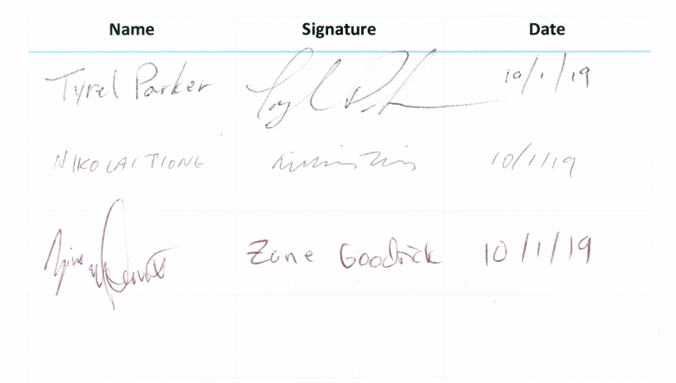

**Consent to Electronic Signatures:**

|  |  |  |
| --- | --- | --- |
| Name | Signature | Date |
| Zane Goodrick | **Zane Goodrick** | **02/22/2020** |
|  |  |  |
|  |  |  |
|  |  |  |
|  |  |  |

**Addition of team member, Joel Berain**

|  |  |  |
| --- | --- | --- |
| Name | Signature | Date |
| Zane Goodrick | **Zane Goodrick** | **02/26/2020** |
|  |  |  |
|  |  |  |
|  |  |  |
|  |  |  |